JS-Control flows

**Date: 18-05-2024**

<body>

    <script src="controlFlow.js"></script>

</body>

1. Write a program to check eligible to vote. (eligible to vote if age 18+)
   * age = 24;
   * **Display message: "You are eligible to vote"**

// Question 01

var votingAge = 18;

if (votingAge < 24) {

    console.log("You are eligible to vote");

}

1. Write a program to check whether a given number is even or odd.
   * num = 27;
   * **Display message: "Number {num} is odd/ even"**

// Question 02

const number = prompt("Enter a number: ")

if (number % 2 == 0) {

    console.log("The number is even");

}

else {

    console.log("The number is odd");

}

1. Write a program that displays the largest integer among two integers.
   * num1 = 10;
   * num2 = 2;
   * **Display message: "{num1} is large than {num2}"**

// Question 03

const number1 = prompt("Enter number 1: ")

const number2 = prompt("Enter number 2: ")

if (number1 > number2) {

    console.log("{num1} is large than {num2");

}

else {

    console.log("{num2} is large than {num1");

}

1. Write a program that determines if a year is a leap year.
   * year = 2024;
   * **Display message: "{year} is leap year"**

// Question 04

function isLeapYear(year) {

    return (year % 4 === 0 && year % 100 !== 0) || (year % 400 === 0);

}

const year = 2024;

if (isLeapYear(year)) {

    console.log(`${year} is a leap year`);

} else {

    console.log(`${year} is not a leap year`);

}

1. Write a program to check alphabet it is vowel or consonant using switch case.
   * alphabet = 'a';
   * **Display message: "{alphabet } is vowel/ consonant"**

// Question 05

let alphabet  = 'a';

switch (alphabet) {

    case 'a':

    case 'e':

    case 'i':

    case 'o':

    case 'u':

    case 'A':

    case 'E':

    case 'I':

    case 'O':

    case 'U':

        console.log(alphabet + " is vowel");

        break;

        console.log(alphabet + " is consonant");

}

1. Write a program to compute the sum of the first 10 natural numbers using a **for** loop.
   * **Display message: "The first {number} number's sum is {sum}."**
2. Write a program to print given shapes.
   * **For loop**

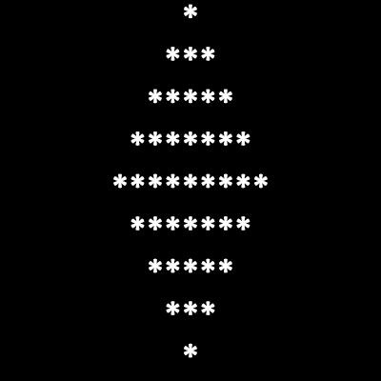

* + **while loop**

